William Eddy – Database Management

**HW D**

**Part A:**

1. Draw a rough ERD (Conceptual Data Model) between the following given entities using the facts stated above. Be sure to show the maximum and minimum cardinality.

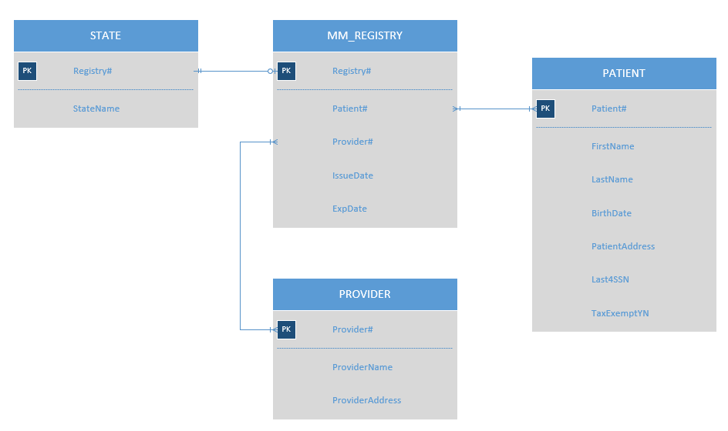

1. Assume the entities given above are the only ones. List the unique identifiers of each entity. If none exists, then apply a surrogate one.

STATE: Registry#

MM_REGISTRY: Registry#

PATIENT: Patient#

PROVIDER: Provider#

1. Identify all functional dependencies:

STATE – State, *Registry#*

MM_REGISTRY – *Registry#,* *Provider#,* *Patient#,* IssueDate, ExpDate

PATIENT – *PatientNumber*, PatientName, *Registry#,* PatientAddress, Last4SSN, TaxExemptYN

PROVIDER – ProviderName, ProviderAddress, *Provider#*

1. Identify all attributes: (Attach attribute list to each entity it belongs to)



1. Draw the completed ERD to include all attributes. Be sure to complete this in Visio.

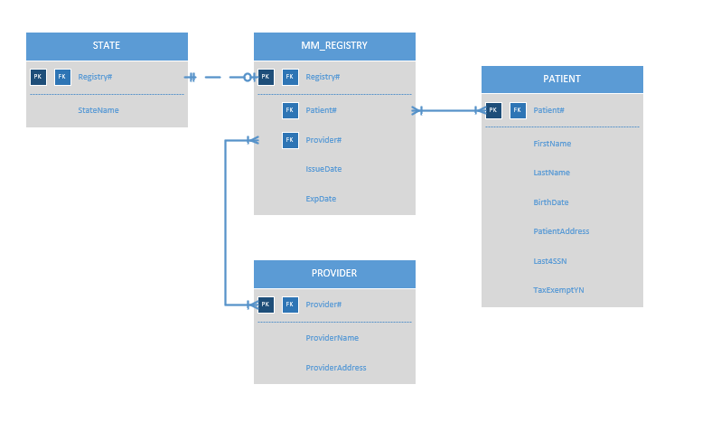

**Part B:**

Pirate University provides educational classes to students. You have been asked to design a database showing the entities and their relationships to facilitate this operation. The facts given below are the result of many user interviews and should be used to design the database. Be sure to complete the following:

* You are to determine the entities and fields needed for this database.
* Use surrogate keys as needed.
* Draw the relationships between each entity using the crow’s feet design.
  + If any relationship has a many-to-many cardinality then you are to create an intersection table between the two.
* Do not worry about including foreign keys.
* Use Visio to complete this assignment.

Pirate University facts you should use to design the database are:

* The university can have many departments, but a department will belong to only 1 university
* A professor will teach in only one department, but a department can have many professors.
* A student will belong to only one department, but a department can have many students.
* A department will provide many courses, but a course will be taught by only one department.
* A professor can teach many courses and a course can be taught by many professors.
* A student can take many courses and a course can be taken by many students.

How to Begin

1. Do all your design work on blank scratch paper
   1. Write a box for each entity and label it.
   2. Create your relationships by drawing lines between entities as needed.
   3. If there are any many-to-many relationships, then create an intersection entity.
   4. If the new intersection entity created also has a many-to-many relationship, then create another intersection entity between those two.
   5. Determine all the fields for each entity.
   6. Make sure the unique identifier (later turns into the primary key) determines every field and that each entity is fully normalized.
   7. Review the finished design carefully
   8. Continue on the next page.
2. Draw a rough ERD (Conceptual Data Model) between the entities using the facts stated above. Only include the entity name and be sure to show the maximum and minimum cardinality. Be sure to break down all many to many relationships.

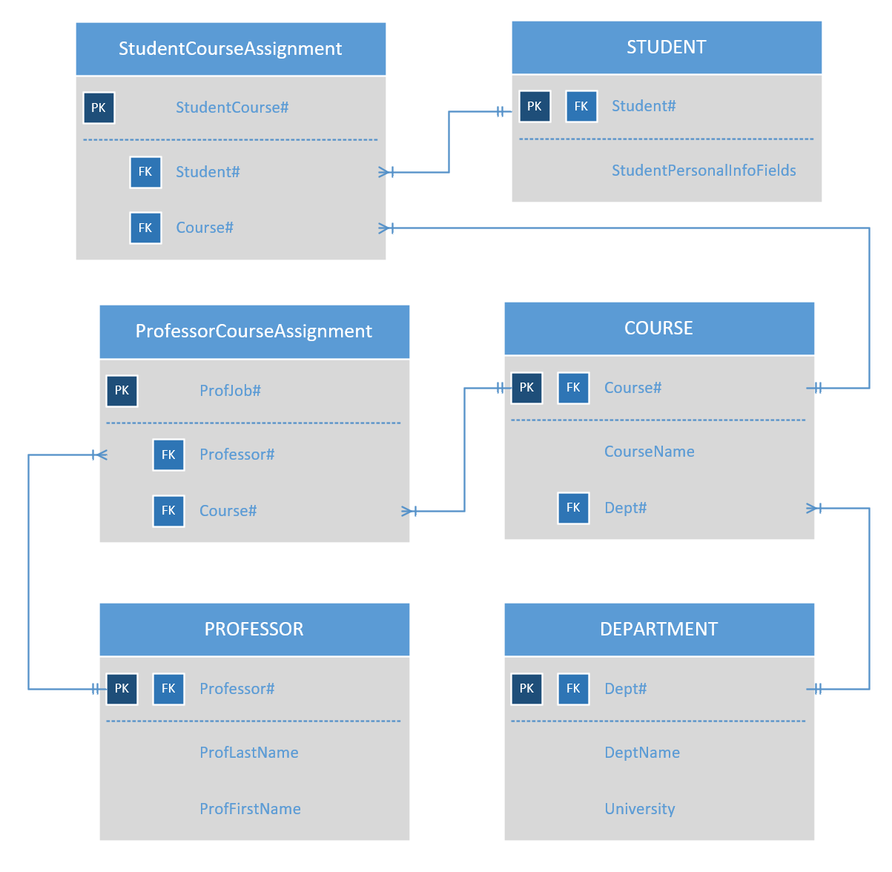

1. Create a unique identifier of each entity and list it below.

* STUDENT_COURSE_ASSIGNMENT - StudentCourse#
* STUDENT - Student#
* PROFESSOR_COURSE_ASSIGNMENT - ProfJob#
* COURSE - Course#
* PROFESSOR - Professor#
* DEPARTMENT - Dept#

1. Determine all needed (ONLY NEEDED) attributes for each entity. (Put into normalized sentence structure and underline the unique identifier)

* STUDENT_COURSE_ASSIGNMENT - StudentCourse#, *Student#, Course#*
* STUDENT - *Student#,* StudentPersonalFields
* PROFESSOR_COURSE_ASSIGNMENT - ProfJob#
* COURSE - *Course#,* CourseName, *Dept#*
* PROFESSOR - *Professor#,* ProfLastName, ProfFirstName
* DEPARTMENT - *Dept#*, DeptName, University

1. Draw the completed ERD to include all attributes. Be sure to complete this in Visio and then copy and paste below.

